**Coding Challenge-1**

**Question 1:Exploratory data analysis (EDA) in Databricks &Visualizing data in Databricks**

**Solution:**

**Exploratory data analysis(EDA):** EDA is a crucial step in the data analysis process as it helps us to understand the structure and characteristics of the dataset. It basically includes methods for exploring data sets to summarize their main characteristics and identify any problems with the data. Databricks provides us tools like built in analysis and visualization which can help us to gain insights on data and also helps us in data analysis.

**Visualizing data in Databricks:**

**STEP1:** First a table is created and its contents are displayed:

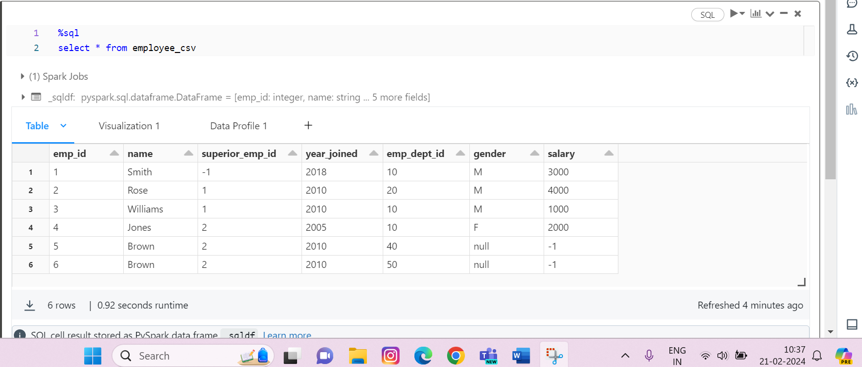

**--------Continued Below--------**

**STEP2:** After this by clicking on the ‘+’ icon we can create different types of visualizations as per the requirement. There are many other visualizations available like pie chart, scatter, line chart, area chart, histogram etc. Here I have used Bar graph for example:

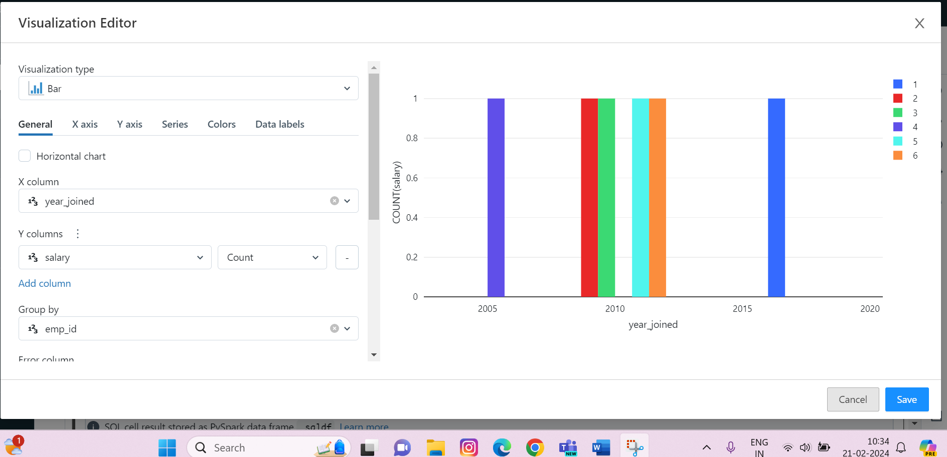

**STEP 3:** Afte creating the visualization charts we can save them by clicking the save option and they will then be saved next to our table:

**We can also change the colours of the visualization as per our needs for eg**:

**We can also edit, delete, view or download the visualization charts.**

**Data Profile**

After visualization we can also create data profile by clicking the ‘+’option:

So, basically visualization helps us in exploring our data in a easy manner with the help of different graphs or charts and provides us a more clear and concise way to gain insights from the data.